**Ms. Pursel’s Back to School Newsletter**

***Welcome to third grade!*** I am very excited to have the opportunity to be working with you and your student this school year. As the school year gets underway I will be communicating any important information to you primarily through **email and through my monthly newsletter**. I also have a **class website** I will be updating on a regular basis with homework and other important information updates. My class website can be found at [**http://rebekahpursel.weebly.com/**](http://rebekahpursel.weebly.com/)**.** The information below gives some information about S.I.S. and some policies in my classroom.



**Contact Information**

Please feel free to contact me anytime about your student’s performance or any questions you might have. You can contact me by phone or by email.

**Phone:** 520-625-3502

**Email:** [**rpursel@sahuarita.net**](mailto:rpursel@sahuarita.net)

*(The fastest way to contact me is through email.)*

**Behavior**

In order to have a positive learning environment for all of the students it is important that students come to school ready to learn and have a positive attitude. The behavior system I use is based on a color coded system. All students will begin with their frog on the color green, which represents that the student has demonstrated good behavior. If students are demonstrating exceptional behavior throughout the day I will have them move their frog to the blue color, which represents that the student has done everything asked of them and more. If a student demonstrates disruptive or disrespectful behavior they will be given 1-2 warnings. After the student has been warned about a behavior they will move their frog from green to yellow. (The yellow represents that the student has been warned.) As a consequence they will lose their morning bathroom break. If the student continues to display inappropriate behavior they will move their frog to red, which will lead to a principal referral and/or parent contact. ***Key: Blue-Great; Green-Good; Yellow-Warning; Read- Poor/ Referral and/or parent contact.***

**Basic School Information**

School starts at 7:25 a.m. If students are late they will be marked tardy. *(If a bus is late students are not marked tardy.)* After a student has been tardy 3 times they have lunch detention. If the student is tardy 5 times they will have to serve an after school detention, which would be on a Tuesday. *(Please be on time!!!)* School ends at 2 p.m., except on Wednesdays in which students will be dismissed at 1 p.m.

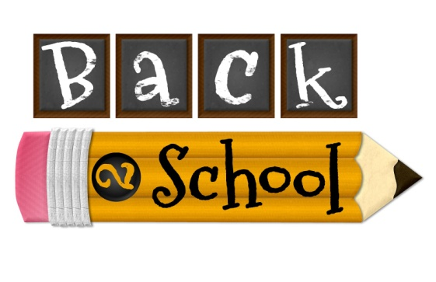





**Dress Code**

Students are to wear clothing that meets the requirements of the school dress code.

Shirt Colors: Red, Blue, White, Gray

Pant/Short/Skirt Colors: Denim, Khaki

**Lunch**

Students can bring a packed lunch or can buy lunch. If students bring a packed lunch they will put their lunch in a designated place in the classroom. If students are buying their lunch you can have your student bring in their lunch money with their name and Student ID and I will make sure it gets to the cafeteria. You also have the option of putting money in their lunch account on-line.



**Homework**

Students will be assigned homework on a nightly basis in order to help them to further practice the skills they are learning in the classroom. Students will have language arts/spelling homework as well as a nightly math assignment and AR reading. Students are expected to turn in their homework on a daily basis. If a student does not turn in their homework assignment they will have to stay in during their morning bathroom break and/or lunch recess to complete the task they did not turn in.



**Schedule**

**7:25-** Morning Work

**7:45-** DMS

**8:15-** Mini Lesson

**8:45-** Literacy Stations

**10:25-** Bathroom Break

**10:40-** Problem Solving

**11:00-** Enrich/Reteach

**11:35-** Lunch

**12:15-** Math

**1:05-** Specials

**2:00-** Dismissal

**12**



**Birthdays!!!**

Students are more than welcome to bring in a treat on their birthday to celebrate with their classmates. If treats are brought in we will celebrate in the Cafeteria during lunch time, which starts at 11:35. A total of 26 treats would need to be provided.